QSP 8.3-1: Control of Nonconforming Product

Approvals

V.P. Regulatory Affairs Date

Regulatory Affairs Coordinator Date

Operations/Production Manager Date

Document Control Administrator Date

Rev | Date | Description of Change
0 | N/A | Initial release.
1 | 04/02/2014 | Added clarity to the procedure and added specific responsibilities.
2 | 08/29/2018 | It is updated for clarity and responsibilities and reference to additional forms.
3 | 10/31/2018 | Revised all sections 1.0 to 11.0
4 | 07/29/2019 | Corrections to section 6.3, 6.6, 7.1, 7.3, 7.3.5, and 8.4 to show correct QSP 8.5-1 and to include 'Feedback Team.'
5 | 5/14/2020 | Changed the Approvals from Director of Operations to QA/RA Manager;  3.0 Reference Documents – added QSP 8.2-2, WI 1, WI 1.1, WI 1.2, and WI 4.2;  4.0 thru 7.0 – not in document added each section  7.0 Procedure – this section has been updated according to the updated Form 8.3-1-1.  10.0 RMA – moved from original 7.0 Procedure  11.0 Actions in Response – section number changed  12.0 Measurement Metrics – section number changed  13.0 Records – section number changed  14.0 Flowchart - added
6 | 07/15/2020 | Added requirement to record justification if investigation is not needed (7.4.1).
7 | 11/3/2020 | Changes to WI 1.2, WI 1.3, and WI 1.2-1, alignment of WI numbers will change in the Reference Document and procedures 7.0(7.1)
8 | 03/13/24 | - Purpose: rewrite first paragraph  - Scope: rewrite  3.0 Reference Documents: additional reference added  5.0 Abbreviations: removed EVP; added DCA, MR, RA/QA  6.0 Responsibility and Authority: update to this document…this procedure…; added The President…  7.0 Procedure, section 7.2 Documentation, 1st bullet: added Completion section 1.0… removed last bullet For Reworks, refer to 7.5 Disposition/Rework; Section 7.3 Segregation, 1st bullet: change bin to container; 3rd bullet: changed to Place the form inside the container and cover; 7.3.1 added the label reference information; last bullet refers to segregated area; Section 7.4 Evaluation: update the procedure; section 7.5 Disposition: update to the President authorizes the disposition…; Section 7.5-1-1 Scrap … the NCR product will be placed on the 2nd floor in Room 117. Changed Scrapped products or components will be disposed.; 7.5.1.2 update to Evaluator will notify the supplier…; 7.5.1.3, 2nd bullet: update to DCA…7.5.1.4, added 3rd paragraph; Section 7.5.1.4 Rework – revamp section according to form; Under NOTES, 1st bullet: updated to the President…; removed bullet #3, it was a repeat from section 7.3.  9.0 Closing the Nonconforming Product Report: update to the President determines…, added DCA will complete…; update to all bulleted lines  10.0 Return Merchandise Authorization (RMA), 10.1: Update to VP of Accounting…  Added Section 7.5.1.3 SCAR process  11.0 Actions taken to Nonconforming Products Detected after Receiving (Internal): this is a correction to title; section 11.1 – update first sentence to: If a product is nonconforming after going through the receiving process  12.0 Measurement Metrics, 12.2: rewrite sentence;
9 | 8/11/2024 | Modified Section 7.5.1.2 to include SCAR form to send to supplier  Added Form 8.3-1 Supplier Corrective Action Report (SCAR) to Reference Documents section  Added Operations/Production Manager to Approvals –  Changed President to V.P. Regulatory Affairs in Responsibilities
10 | 3/21/2025 | 3.0 Updated Referenced docs  7.0 Updated Procedure  7.6 Removed “Disposition for Rework of Single-Use Product”  8.0 Removed “Actions Taken to Nonconforming Products Detected after Receiving (Internal)”
11 | 7/14/2025 | 3.0 Updated titles for Form 7.5-1-3 and 7.5-1-4  Added Form 8.3-1-3 and 8.3-1-4  5.0 Added CAPA, PRRC, and SCAR to abbreviations  Removed MR  6.0 Clarified responsibilities for the Production Team, Production Manager, and Regulatory to ensure alignment and accountability  Removed Management representative and added PRRC  7.1 Updated titles for Form 7.5-1-3 and 7.5-1-4  7.2 Added Form 8.3-1-3 and 8.3-1-4  Added notification to supplier for receiving inspection discrepancies  7.3 Clarified requirement steps for NCR, SCAR and CAPAs during the evaluation procedure  7.4 Clarified Rework between Internal and Supplier  Rephrased the return to customer decision  10.0 Updated flowcharts to match with each corresponding type of nonconformance

PURPOSE
This procedure establishes the methods to ensure that products that do not conform to requirements are segregated and controlled to prevent unintended use or delivery. The control and related responsibilities and authorities for identifying, documenting, segregation, evaluation, and disposition of nonconforming products are defined in this procedure, per the Quality Manual requirements.

The Company deals with a nonconforming product in one or more of the following ways before delivery:
- Taking action to eliminate the detected nonconformity
- Taking action to preclude its original intended use or application of the material or device
- Authorizing its use, release, or acceptance under concession

When detecting a nonconforming product after delivery or use has started, then appropriate action is taken.

SCOPE
This procedure applies to Tulip Medical personnel trained in receiving and production and have training on how to handle all nonconforming materials, customer returns, and products manufactured internally or received from suppliers by Tulip Medical Product.

REFERENCE DOCUMENTS
QM1 Quality Manual
FDA CFR - Code of Federal Regulations Title 21 820
Form 7.4-2-1 Receiving Inspection
Form 7.5-1-2 Reusable Cannula Assembly & Inspection Form
Form 7.5-1-3 Single Use Assembly for Accessories
Form 7.5-1-4 Single-Use Assembly for Cannulas
Form 7.5-3 Packaging: Kits & Sets
Form 7.5-8 Product Marking & Inspection Form
Form 8.3-1-1 Receiving Nonconformance Report
Form 8.3-1-2 NCR Log
Form 8.3-1-3 Internal Nonconformance Report
Form 8.3-1-4 Destructive and Pull Test Nonconformance Report
Form 8.3-1 Supplier Corrective Action Report (SCAR)
RSK-04 Process FMEA
RSK-07 Reusable Cannula Product
RSK-08 Design FMEA Reusables
RSK-09 Design FMEA
QSP 8.2-2 Customer Feedback - Complaints
QSP 4.2-1 Document Control
QSP 5.6-1 Management Review
QSP 7.4-2 Product Inspection
QSP 8.4-1 Testing, Measurement and Analysis
QSP 8.4-2 Statistical Analysis
QSP 8.5-1 Corrective & Preventive Actions
QSP 9.1-5 Advisory Notices, Recalls & Vigilance
WI 7 Testing Procedures

DEFINITIONS

Nonconformity (NC): Non-fulfillment of a requirement (21 CFR 280.3(q).

Corrective Action (CA): Action to eliminate the cause of nonconformity and to prevent a recurrence.

Preventative Action (PA): Action to eliminate the purpose of a potential nonconformity or other undesirable possible situation.

Segregation: A setting apart or separation of nonconforming product from approved products.

ABBREVIATIONS

CAPA – Corrective and Preventive Action

DCA – Document Control Administrator

PM – Production Manager

PRRC - Person Responsible for Regulatory Compliance

RA/QA – Regulatory / Quality Assurance

SCAR – Supplier Corrective Action Report

VP – Vice President

RESPONSIBILITIES and AUTHORITY

The Document Control Administrator (DCA) is responsible for the maintenance of company documents. This person controls the numbering, sorting, filing, storing, and retrieval of electronic and hard copy documents produced by Regulatory, Management, or by departments within Tulip Medical Products.

The Production Manager serves as the primary point of contact (POC) for supplier communication following receiving inspection. They are responsible for promptly notifying the supplier of any rejected nonconformances or minor cosmetic discrepancies identified during inspection. This includes coordinating the return of nonconforming materials when applicable and ensuring that appropriate documentation is maintained in accordance with quality procedures.

The Production Team is responsible for identifying any nonconformances found during or before assembly inspections and promptly notifying the Production Manager for further action and documentation.

The PRRC is a qualified individual appointed under MDR Article 15 to ensure device conformity, maintain technical documentation, oversee post-market surveillance and vigilance, and issue statements for investigational devices.

The Regulatory Team is responsible for reviewing the nonconformance log, determining the need for a SCAR or CAPA based on recurrence or risk, and compiling an evaluation summary to support disposition decisions. Justifications must be documented if a SCAR or CAPA is not issued

The Vice President of Operations (VPO) or Regulatory Affairs (RA) has the authority to assign change or update this document, ensure compliance with the requirements of this procedure, and the power to inspect and approve or disapprove segregated nonconforming components and products.

The V.P. of Finance is responsible for the final disposition of a nonconforming component and has the authority to assign change or update this document, ensure compliance with the requirements of this procedure, and the power to inspect and approve or disapprove segregated non-conforming components and products.

PROCEDURE

Identification: Inspection of products or components will be done in accordance with QSP 7.4-2 Product Inspection. Each inspection will have its own form where non-conforming items will be referenced upon finding.

Form 7.4-2-1 Receiving Inspection

Form 7.5-1-2 Reusable Cannula Assembly & Inspection Form

Form 7.5-1-3 Single Use Assembly for Accessories

Form 7.5-1-4 Single-Use Assembly for Cannulas

Form 7.5-3 Packaging: Kits & Sets

Form 7.5-8 Product Marking & Inspection Form

Documentation: All production personnel must complete one of the following nonconformance report forms immediately after identifying a nonconforming item:

Form 8.3-1-1 (Receiving Nonconformance Report)

Form 8.3-1-3 (Internal Nonconformance Report)

Form 8.3-1-4 (Destructive and Pull Test Nonconformance Report)

DCA will provide the NCR number from the next in sequence in the NCR Log 8.3-1-2

Only one nonconformity discrepancy will be recorded per Nonconformance document

Pull test are required per WI 7 Testing Procedures but no evaluation will be required

Suppliers are to be notified of discrepancies upon discovery at receiving inspection

If the discrepancy is major and outside of conformity, an RMA number must be requested from the supplier to return the products or components.

If the discrepancy is minor and cosmetic, no RMA is required, but the supplier should be informed

Evaluation: Determine the nonconformance

The evaluator determines the need to investigate and notify the persons or organizations responsible for the nonconformance [21 CFR 820.90(a)].

Write a justification if no evaluation is necessary.

A risk evaluation must be completed, refer to Tulip’s FMEA RSK-04, RSK-07, RSK-08, AND RSK-09.

Review the nonconformance log to determine if similar or related NCRs have been previously documented

A SCAR shall be issued Form 8.3-1 if the nonconformance is determined to be recurring within the past 12 months or if it poses a significant quality or regulatory risk, provide a justification if no SCAR is needed

After determining whether a SCAR is required, proceed with returning the component/product to the supplier

A CAPA shall be initiated when a nonconformance indicates a systemic issue, provide a justification if no CAPA is needed

An evaluation summary shall be compiled using all relevant information from the NCR, SCAR, Customer response and CAPA to support the disposition decision

Disposition: The final settlement of nonconformance products or components.

The President authorizes the disposition of the nonconforming product or component. The specific nonconforming product or component dispositions are:

Rework

If nonconforming products are identified during receiving inspection, they shall be returned to the supplier. It is at the supplier's discretion to determine whether the product or component is suitable for rework

If a nonconformance is identified during internal assembly, rework may be performed to salvage and reuse portions of the components when appropriate (e.g., cutting a stem from a cannula assembly for reuse in a shorter-length cannula)

Scrap – If the final disposition is to not use the product, the products or components will be disposed. Reusable and single-use products are new products. Therefore, they do not fall under the FDA Disposal of Contaminated Devices and will be disposed as scrap metals.

Returned to supplier – If the product was returned and could not be reworked, the supplier retained and disposed of it

Use as Is – Use of the nonconformance when it does not affect the safety and effectiveness of the final product.

For 'use as-is' dispositions, the evaluator must verify and document that the nonconformance does not create an out-of-specification condition that impacts FDA or market approval requirements.

The PRRC will document and sign the justification for the use of nonconforming products. An example of use as is will be if the packaging is only fractions off comparing to another packaging within the lot received.

DCA will remove the “Nonconformance” label and release the product to Production for inventory.

Note: Inventory Adjustments are to be completed prior to scrap disposition of the product or component

Closing the Form:

The final approver of disposition is to be made by a VP

DCA will record and log upon completing the final checklist in reference with QSP 4.2-1 Document Control.

Actions Taken to Nonconforming Products After Delivery

Tulip will take appropriate action if a customer calls with a defected product per QSP 8.2-2

QSP 9.1-5 Recalls, Corrections & Removal describes issuing advisory notices by applicable regulatory requirements. This procedure is capable of being put into effect at any time. Records of actions relating to the issuance of advisory notes are maintained.

The VP of Finance or VPO must approve a returning nonconforming product from a customer. The VPA will assign an RMA through Tulip's sales order system called SOS.

Measurement Metrics

Nonconformance will be tracked by type of issue and product for review of systemic problems that alert the need for corrective action. (see Form 8.3-1-2 NCR Log)

Take immediate action for Safety-related concerns. Safety-related concerns do not require a trend or a review of risks to take action.

Measurement metrics will be updated to present at each Management Review per QSP 5.6-1 and analyzed per QSP 8.4-1.

Data sampling and collection performed for statistical techniques re-applied as necessary per QSP 8.4-2.

- FLOWCHART
RECEVING INSPECTION
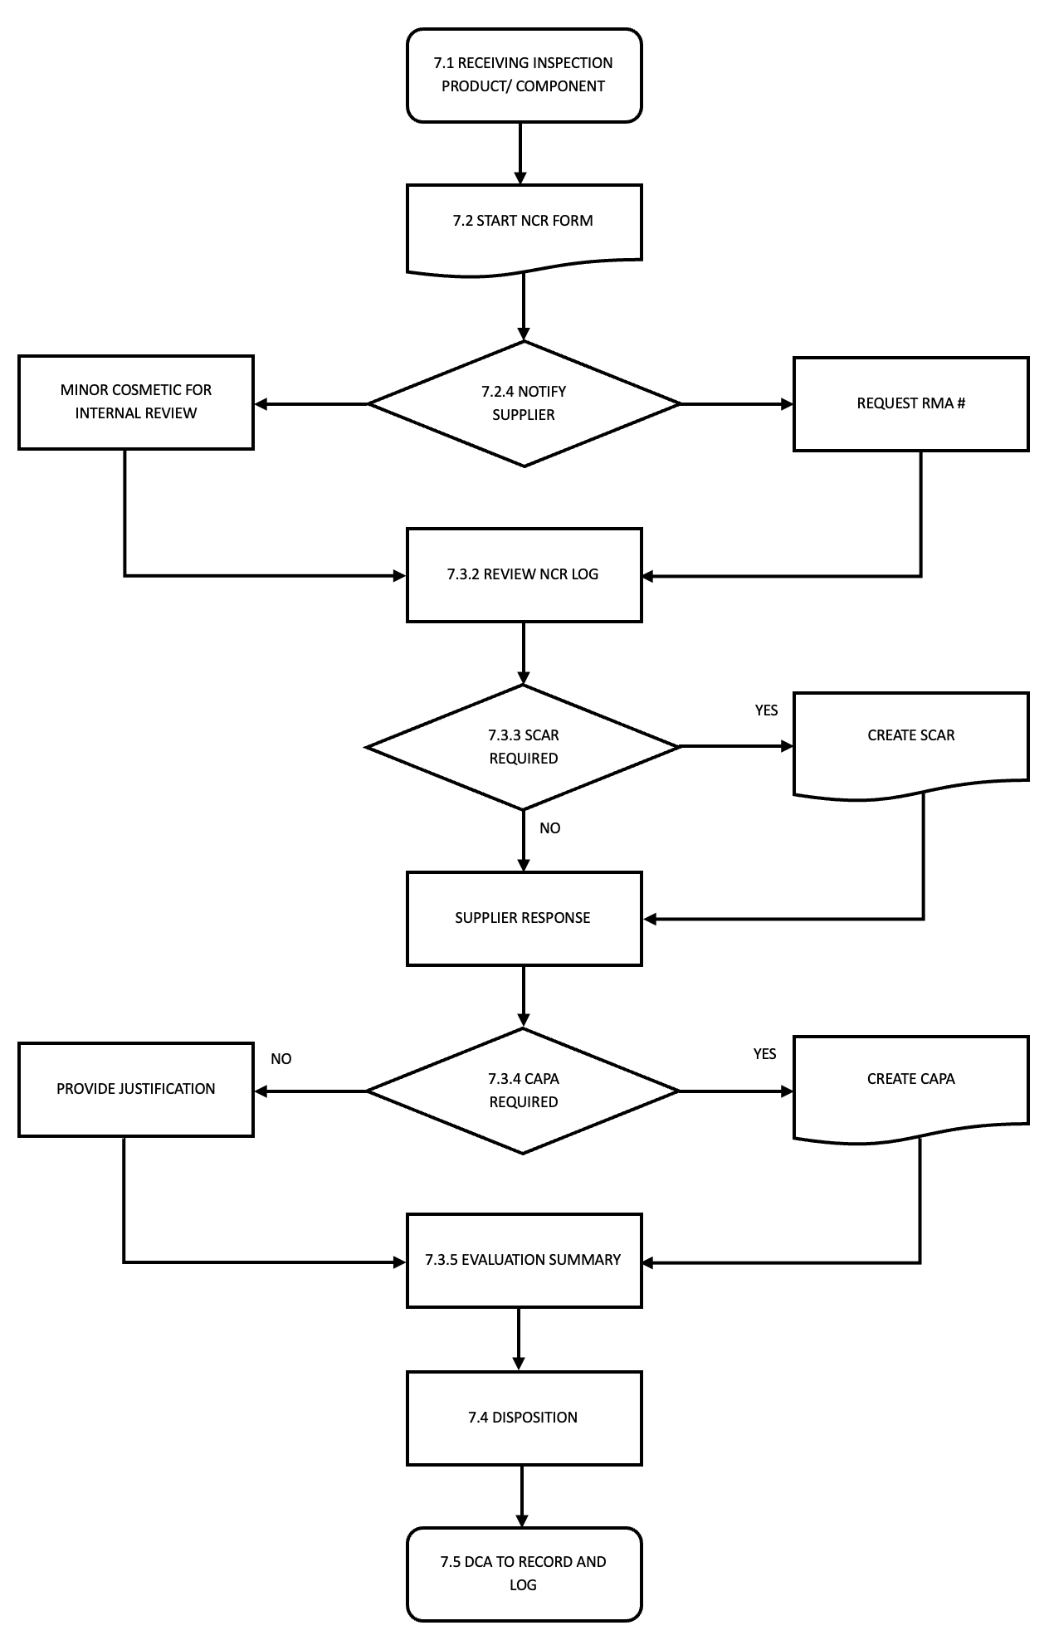

INTERNAL NONCONFORMANCE
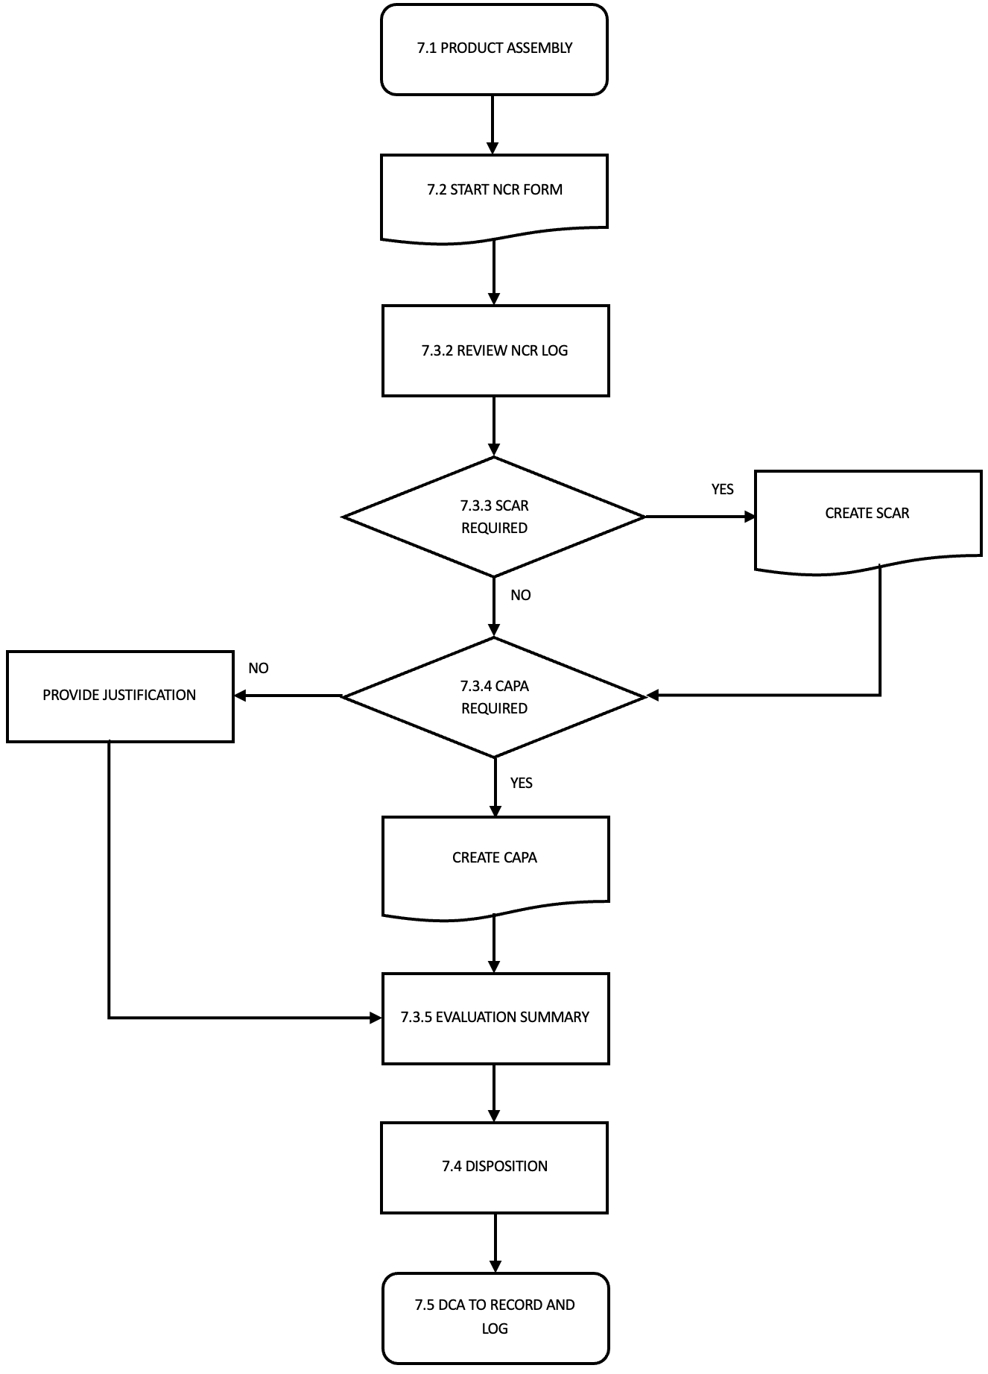

Destructive and Pull Test Nonconformance
